Lamborghini
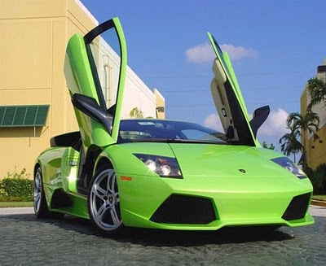
The Lamborghini is an Italian car. Like most car companies they did not start off with cars but tractors.
As of 2010, Lamborghini product range consists entirely of mid-engine two seat sports cars. The roof and doors of the Murcielago are made of steel. The rest of the car is made from carbon fibre.
Lamborghini is an Italian sports car manufacturer. But it is sold all around the world.
The company was founded in 1963, producing cars that are symbols of opulence and wealth. The company is now owned by Volkswagon. Lamborghinis costs €165,000. The top speed of a Lamborghini is 205 mph.
By Joshua Rushe (Mr Gordon’s 5th class)

