Why it rains
The water cycle, also known as the hydrologic cycle, is the journey water takes as it circulates from the land to the sky and back again.
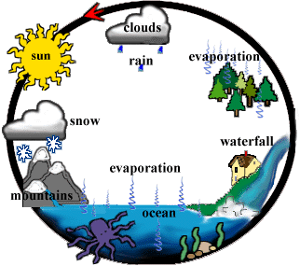

The sun’s heat provides energy to evaporate water from the earth’s surface – oceans, lakes etc. Plants also lose water to the air – this is called evaporation.
The water vapour eventually condenses, forming tiny droplets in clouds. When the clouds meet, cool air over land, precipitation or rain, sleet or snow is triggered, and water returns to the land or sea. Some of the precipitation soaks into the ground.
Some of the underground water is trapped between rock or clay layers. This is called groundwater, but most of the water flows downhill as runoff – above ground or underneath ground, eventually returning to the sea as slightly salty water.
And that’s why it rains!
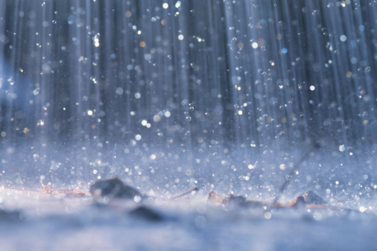
By Aisosa ( Mr Carty’s 6th class)

