Why we wash our hands
We clean our hands so we don’t spread germs. If we spread germs we and others could become ill.
When we wash our hands we need soap, water and of course our hands.
First of all we wet our hands. Then we place a small amount of soap on our hands. Then we rub our hands together forming a lather. We make sure to wash our fingers too.
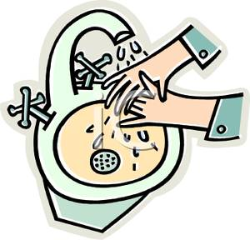
We wash our hands at a sink before and after meals and after using the toilet. At other times we wash our hands whenever they get dirty.
We can get all types of different soaps. Hand sanitizers can be carried anywhere. It is important to wash our hands at a hospital and before cooking. We also wash our hands after playing with a pet or after petting animals in a farm or zoo.
By Abbie Lambert (Mr Molloy’s 4th class)

